**REACT**

Create a new React Application with the name “myfirstreact”, Run the application to print “welcome to the first session of React” as heading of that page.

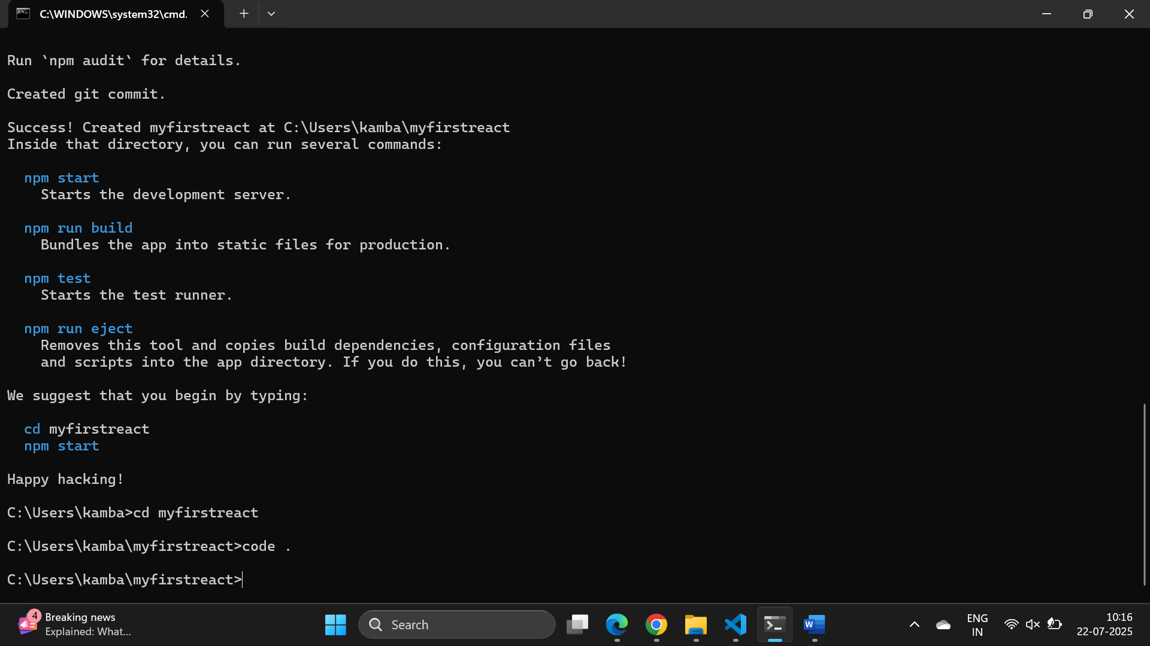

**App.js**

import React from 'react';

function App() {

  return (

      <h1>Welcome to the first session of React</h1>

  );

}

export default App;

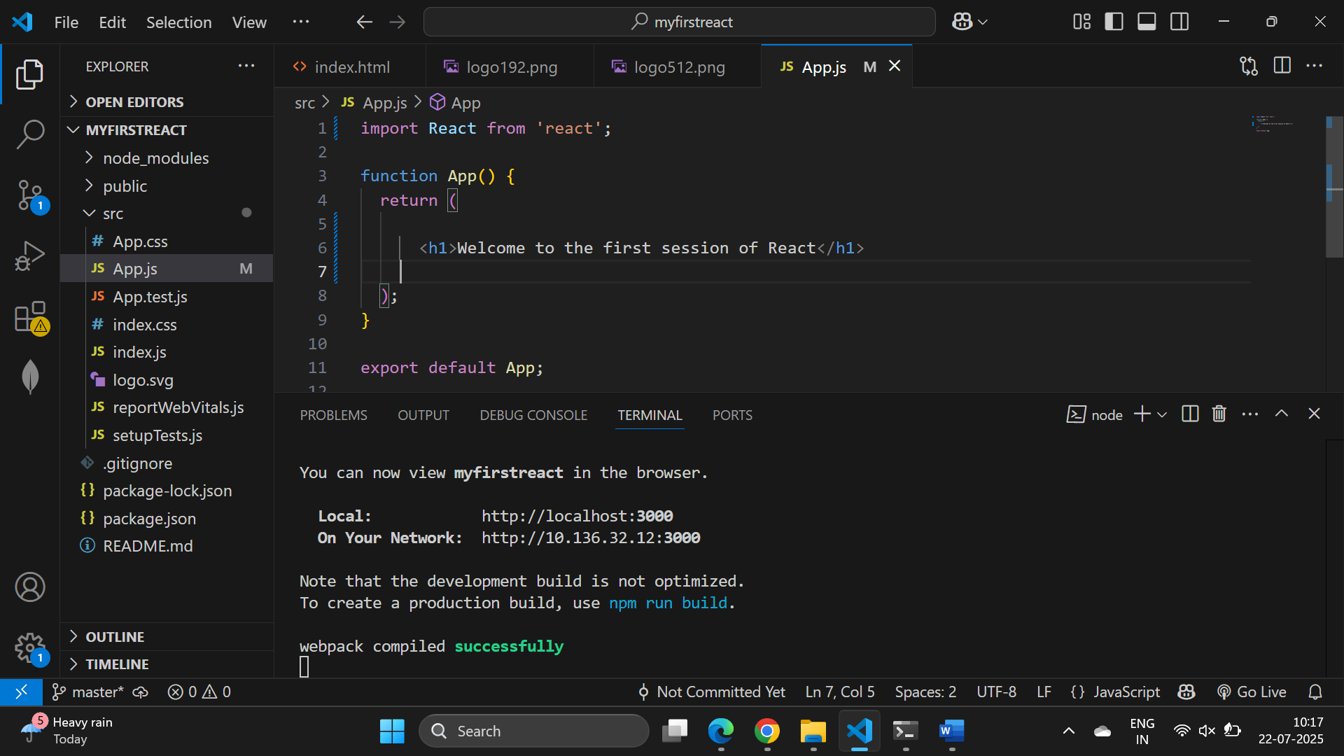

OUTPUT

